DASH GCP VM Access Guide

Input Guide
This section outlines the input parameters required for provisioning GCP Virtual Machines using the DASH Portal. Each parameter includes a description, available options, usage guidance, and notes on valid combinations when applicable.

Input Parameter | Description | Values Provided | Value Guidance | Valid Combinations
os_template | Pre-configured base Operating System image used for the VM. | ubuntu-2004-lts, ubuntu-2204-lts,ubuntu-2404-lts,rhel-9, rhel-8, windows-2019, windows-2022 | Choose an OS required for your workload. | N/A
machine_type | GCP VM size to allocate. | n1-standard-1, n1-standard-2, n1-standard-8, n2-standard-4, e2-standard-2, e2-standard-4 | Choose based on workload requirements (vCPU, memory). | N/A
region | GCP region where the VM will be deployed. | us-central1, us-west1, us-east1 | Choose the region that is geographically closest to your end users or integrated services to minimize latency and improve performance. | N/A
service_name | The name of the service to install on the VM. | docker, minio, mongodb, nfs, nginx, postgres, kubernetes, llavallm, none | Choose based on the role the VM will serve (eg: Docker for container hosts, Postgres for DB) | N/A
hostname | A unique name to identify the VM. | Any alphanumeric string with dashes | Use clear naming conventions for easier resource management. | N/A
Sample Input Selection:
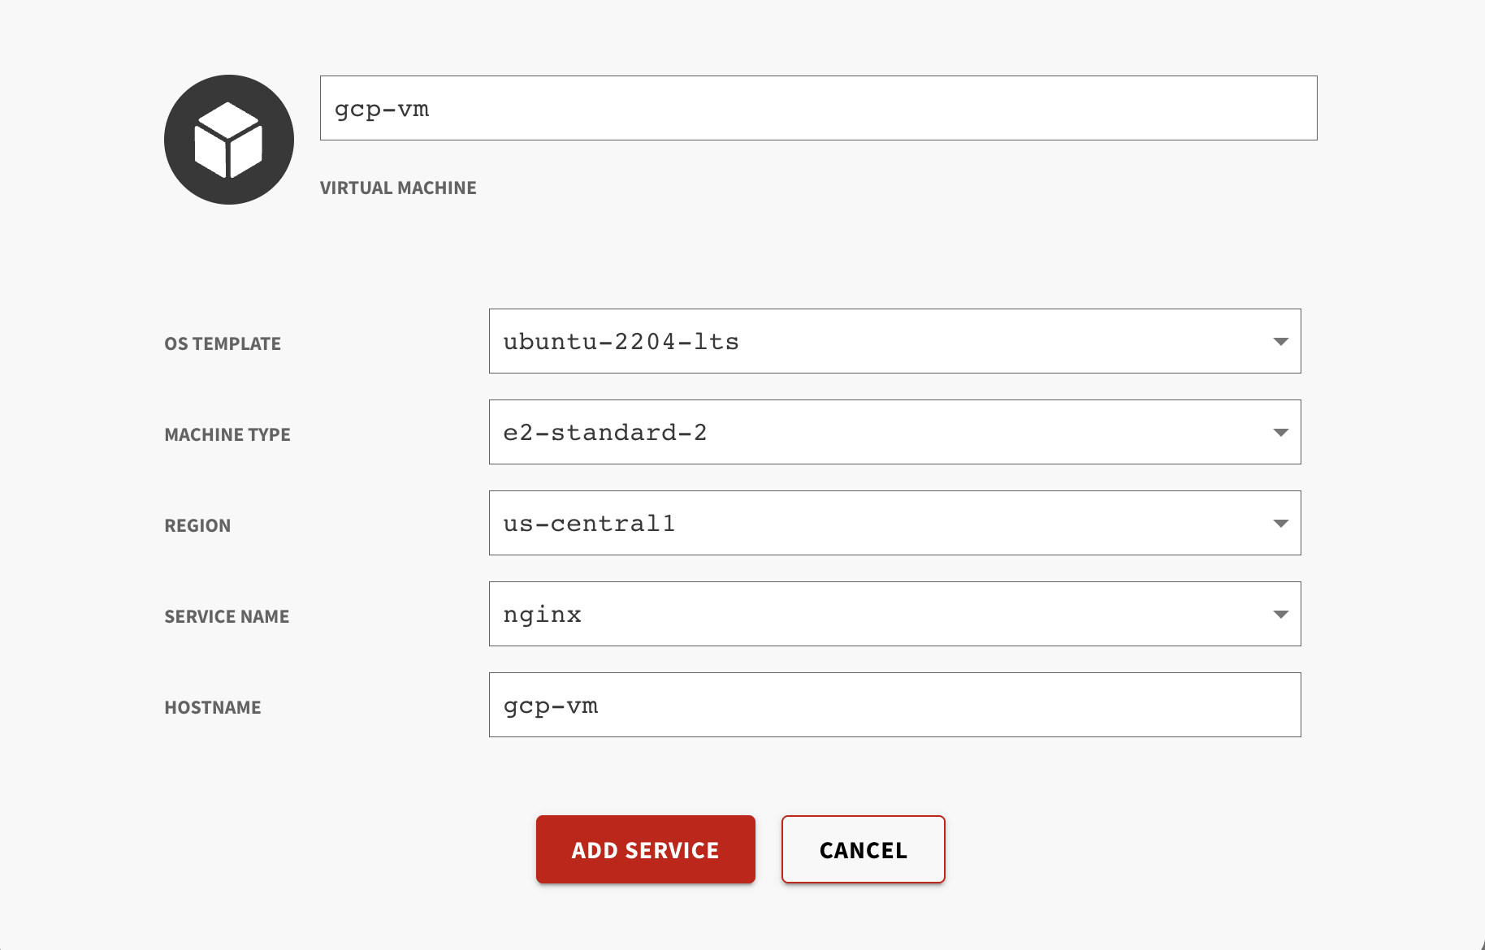

Output Guide
This section outlines the output values generated after GCP Virtual Machine provisioning through the DASH Portal. These outputs can be used to access, manage, and connect to your virtual machine.

Outputs | Description | Example Value
Authentication | Connect to VM directly using external_ip. | ssh dash@35.202.249.240
connection_info | Connect to the VM using gcloud-cli. | gcloud compute ssh dash-demogcpv-yavb-001 --project dash-gcp-services --zone us-central1-a
external_ip | Public IP address of the VM. | 35.202.249.240
loadbalancer_endpoint | Frontend IP to access the application in the host machine. | http://34.54.97.200
network_ip | Private IP address of the VM. | 10.30.0.46
Password | Password to SSH into the VM. | h51wKjtf
Username | Username to SSH into the VM. | dash

Steps to SSH to GCP Virtual Machine:
Use the below commands to connect to GCP Virtual Machine.

- SSH to the Virtual Machine using Public IP : (Linux-based OS)
  - Copy the value of the Authentication displayed in output and run the command in the terminal.
Example: ssh dash@35.202.249.240
- RDP into the Virtual Machine (Windows-based OS)
  - Open Remote Desktop Connection (mstsc on Windows).
  - Enter the Public IP Address (e.g., 35.202.249.240).
  - Use the username (Username) and password (Password) from the outputs.

- Login to Virtual Machine from Local Machine using gcloud: (applicable only for users with access to Google Cloud Platform)
  - Install Google Cloud SDK on your local machine: Install instructions.
  - Initialize gcloud (one-time setup): gcloud init
  - Login to the VM via SSH: gcloud compute ssh <VM_NAME> --project <PROJECT_ID> --zone <ZONE>
Example: gcloud compute ssh dash-demogcpv-yavb-001 --project dash-gcp-services --zone us-central1-a

